WHAT’S ON IN WILTSHIRE  SEPTEMBER 2021 |  |  |  | 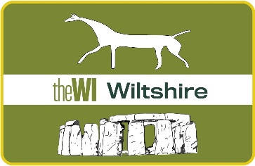
 |  | BECOMING A CIO (Charitable Incorporated Organisation)
Monday 6th September at 7.0pm - Zoom
Come and find out about Wiltshire Federations proposed change to becoming a Charitable Incorporated Organisation and get to answer any questions you may have about it.
This event is free but you must register your interest.
PRESIDENTS & SECRETARIES TRAINING |  |  |  | 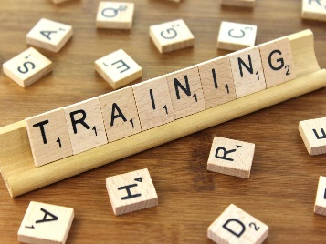
Tuesday 7th September at 7.00pm and Wednesday 8th September at 10.00am - Zoom
A chance to ask a WI Advisor any questions you may have and also meet and share ideas with other Presidents and Secretaries.
This event is free but you must register your interest.
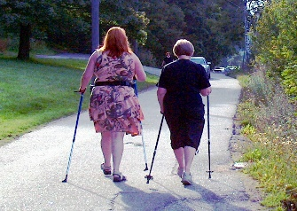 |  |  | NORDIC WALKING (Fully Booked)
Tuesday 14th September 9.30am – 11.00am & 1.00pm – 2.30pm
Castle Combe Village
This event is now fully booked, we have had to organise another session in the afternoon to ensure everyone could attend.
ZIP AROUND THE ZODIAC |  |  |  |  | 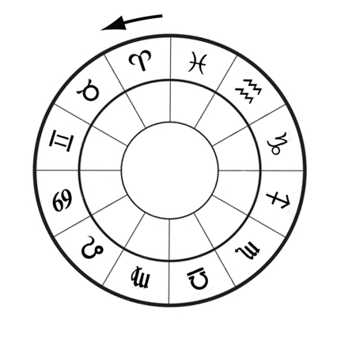
Tuesday 28th August 2.30pm – 4.00pm - Zoom
Clare Manion will host a light-hearted talk about the personality traits from each sign of the Zodiac – Come and hear all about yours!
£5.00 per device
OCTOBER EVENTS – BOOK NOW
New Speakers Morning – Monday 4th October 10.30am – 12.30pm - £2.50
The Body Through the Porthole – Thursday 7th October – 7.00pm - £5.00
WFWI Annual Meeting – Saturday 16th October – 10.30am -1.00pm - £5.00
Ditch the Plastic - Tuesday 26th October – 7.00pm - £5.00
HOW TO BOOK:NEW EVENT BOOKING OPTION AVAILABLE NOW.PLEASE USE/CLICK THE FOLLOWING LINK TO SEARCH FOR ALL UPCOMING WFWI EVENTS:
https://www.trybooking.com/uk/book/search
- Full details of these events and how to book are with your secretary now, online at www.wiltshirewi.org.uk or via WI House in Devizes (01380 739340). If you wish to receive a copy of the flyer via email, please call WI House or email fedsec@wiltshirewi.org.uk and we will get one sent over to you.
- Spaces can be purchased via cheque and posted to WI House, 17 Couch Lane, Devizes SN10 1EB or paid via BACs. We can accept personal cheques for all events. If paying by BACS please send confirmation email to fedsec@wiltshirewi.org.uk.
- Don’t forget to visit the WFWI website (link above) and visit our Facebook Events page for all upcoming Zoom meetings.

