MODERN SLAVERY:
SPOT THE SIGNS, SAVE LIVES
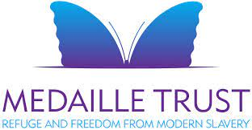 |  | Friday 9th  September 2022  7.00pm – 9.00pm
Modern Slavery is where someone’s freedom is taken away in order to exploit or take advantage of them. Examples include: sexual exploitation, labour exploitation, domestic servitude and criminal exploitation. What are the signs to look for and what can you do to help?
Medaille Trust’s mission is to provide refuge and freedom from modern slavery. They are one of the largest providers of supported safe house beds for victims of modern slavery in the UK.
Broad Hinton Village Hall  Yew Tree Lane, Broad Hinton  Swindon SN4 9RH  PRICE PER PERSON: £6.00 |  |  |  | 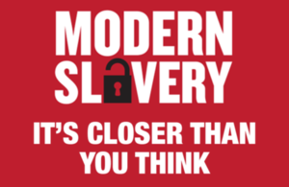
CLOSING DATE: Thursday11th August 2022 (unless fully booked)
ENQUIRIES TO: | Lesley Holdway |  | Tel: 01225 782092
(no ticket sales) |  |  | Email: chair@wiltshirewi.org.uk
Cheques will be banked upon receipt. Email confirmation will sent – tickets will not be used. If a refund is due for any reason it will be sent accordingly.

