Not the Usual Annual Council Meeting 2021
Saturday 16th October 2021
10.30am – 1.00pm - Via Zoom
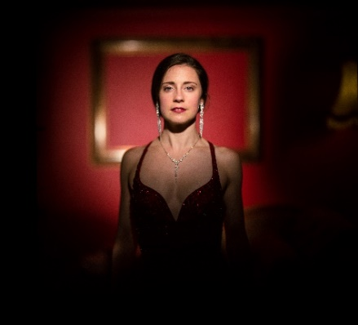 |  | Mary-Jess Leaverland  Mary-Jess, is an English singer and songwriter who won Min Xing Chang Fan Tian (the Chinese version of Britain’s X-Factor), a provincial televised talent competition watched by 70 million people in December 2009.
Tracy Daszkiewicz
Tracy was formerly the Director of Public Health and Safety for the county of Wiltshire, England, where in 2018 she played a leading role in the response to the Novichok poisoning of Sergei and Yulia Skripal in Salisbury.
Each WI is eligible for 1 free delegate ticket.
 | Price per additional attendees £5.00 each.
CLOSING DATE: MONDAY 20TH SEPTEMBER 2021
Cheques will be banked upon receipt. Tickets will be issued after the closing date. If a refund is due for any reason it will be sent accordingly.

Please register __________ devices. We anticipate _______________ members taking part,
Cheque enclosed for: |  | ________________________ | Payable to Wiltshire Federation of WIs  Send to WI House, 17 Couch Lane, Devizes SN10 1EB
BACS payment of: |  | ________________________ | Sent date: |  | ________________________ |  |  | PLEASE USE REFERENCE:  Your WI Name ACM21
Account Name: Wiltshire Federation of WIs Sort Code: 52 30 27 Account No: 35593962
Closing Date: | Monday 20th Sept 2021 |  |  | EVENT: |  | Not the Usual ACM 2021
WI: | ________________________________________________________________________________________________________
Contact: | ____________________________________________ |  |  |  |  |  | Tel: |  | ________________________________
Email@ | _____________________________________________________________________________________________________________________  Email addresses for all devices are required as they will be used to send the Zoom code for the event. PLEASE PRINT CLEARLY  When paying via BACs an email MUST be sent to fedsec@wiltshirewi.org.uk confirming the booking.

