WHAT’S ON IN WILTSHIRE – June / July 2022
 |  | SCRABBLE LUNCH  Bushton Village Hall, Swindon SN4 7PX |  |  | Tuesday 21st June 10.15am – 3.15pm - £12.00 per person  Closing Date: Contact WI House
 |  | Test your word power against other Scrabblers!
GOAT FARM VISIT  Gourmet Goat Farm, Winterbourne Monkton SN 9NW |  |  | Thursday 23rd June from 11.00am - £9.00 per person  Closing Date: Contact WI House
A guided tour and talk with an introduction to the Boer Goats plus freedom to explore the farm on your own.
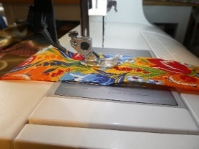 | GET TO KNOW YOUR SEWING MACHINE PART 1  WI House, 17 Couch Lane,  Devizes SN10 1EB |  |  |  |  | Friday 1st or Saturday 2nd July 10.00am – 3.30pm £35 per person  Closing Date: 6th June 2022
Please bring a working sewing machine with power cable and pedal, basic sewing kit of small and large scissors, pins and a pencil and a packed lunch.
You will be able to produce a small selection of samples and a small, covered notebook. All materials included.
DUCHESS OF DEVONSHIRE  Bouverie Hall, Pewsey SN9 5EQ |  |  | Monday 4th July 2.00pm – 4.00pm £20.00 per person  Closing Date: 20th June 2022
Simon Seligman, former Head of Communications at Chatsworth House, talks about the life and times of the Duchess, known to her family as “Debo” and the wife of the 11th Duke of Devonshire.
 |  | TREASURERS TRAINING  Live Event: WI House, 17 Couch Lane, Devizes SN10 1EB |  |  |  |  | Tuesday 5th July (Zoom)  10.00am or 7.00pm  Wednesday 6th July (Live)  10.00am or 1.00pm
BIODIGESTER VISIT  Malaby Biogas, 124 Deverill Road  Warminster BA12 8BD |  |  |  | Thursday 7th or Friday 8th July from 3.00pm £5.00 per person  Closing Date: 23rd June |  |  |  | 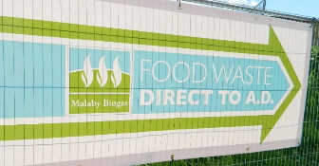
The visit will involve a guided tour and an explanation of the plant systems.
Sturdy footwear is recommended as this is an industrial site.
 |  | DESERT ISLAND DISCS  St Johns Church Hall, Boreham Road, Warminster BA12 9JY |  |  |  |  | Thursday 14th July 2.00pm – 4.00pm £6.00 per person  Closing Date: 23rd June
 |  | An afternoon of nostalgia and entertainment with something to take away and think about at the end.
BUCKLER’S HARD  New date; TUESDAY 6th SEPTEMBER |  |  | 19th July now fully booked  Still at £25.00 per person
- Full details of these events and how to book are with your secretary now, online at www.wiltshirewi.org.uk or via WI House in Devizes (01380 739340).
- To book online go to https://www.trybooking.com/uk/
- Places can be purchased via cheque and posted to WI House, 17 Couch Lane, Devizes SN10 1EB or paid via BACs. We can accept personal cheques for all events. If paying by BACS please send confirmation email to fedsec@wiltshirewi.org.uk.

