 | WILTSHIRE FEDERATION OF WIs  ORDER FORM FOR CALENDARS  AND DIARIES 2022 |  |  |  |  | 
WI:
Please send me |  |  |  | Calendars at £5.00 each
Please send me |  |  |  | WI Diaries at £5.50 each
I enclose a WI cheque made payable to Wiltshire Federation of WIs to cover the Overall total
Signed (WI Secretary)
Address
Tel. No
I will be collecting my WIs parcel from (See attached list) |  |  |  |  | 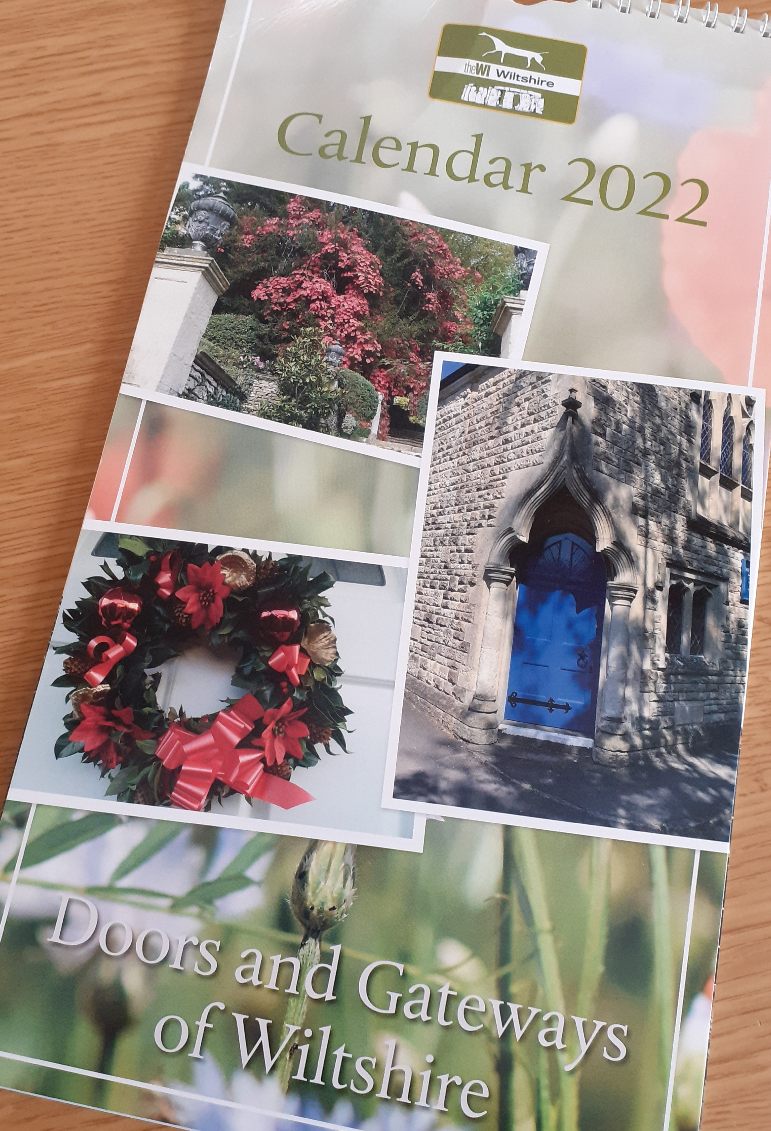
Please return this part of the form to:
WI House, 17 Couch Lane, Devizes SN10 1EB
Tel: 01380 739340
By MONDAY 4TH OCTOBER 2021
Charity Registration No: 229893
FOR WI INFORMATION (Please retain this part of the form for reference)
WFWI ORDER FOR CALENDARS AND DIARIES 2022
All parcels should be at collecting points by 1st November 2021.
Please telephone collecting points before calling for your parcel. Parcels to be collected as soon as possible from the collection point.
Please place your order as soon as possible to avoid disappointment, but in any case not later than Monday 4th October 2021.
You must collect parcels from the collecting points unless you have made prior arrangements for delivery
NB: MY COLLECTION POINT IS
WILTSHIRE FEDERATION OF WIS

PLEASE TELEPHONE THE COLLECTION POINT BEFORE COLLECTING YOUR ORDER

The following members have indicated that they are willing to act as COLLECTION POINTS for Calendar and Diary orders. Packages should be at the collecting points during November. Please collect as soon as you can from the collection point.

CALNE AREA |  | SALISBURY AREA |  | TROWBRIDGE AREA
Mrs Jenny Kostyszyn  102 Beamish Close  Lower Compton  Calne  SN11 8QP  Tel: 01249 817081 |  | Mrs Sue Bourne  Melstock  Nunton  Salisbury  SP5 4HN  Tel: 01722 329734 |  | Mrs Gillian Sheldrake  23 Bond Street  Trowbridge  BA14 0AS  Tel: 07833 448929
Mrs Anna Zebedee-Hardy  51 Wenhill Heights  Calne  SN11 0JZ  Tel: 01249 248605 |  | Mrs Susan Jonas  Spring Gardens  The Dene  Hindon  Salisbury  SP3 6EE  Tel: 01747 820616 |  | WARMINSTER AND WESTBURY AREA  Mrs Mary Lloyd  2 The Piquet  Bratton  Westbury  BA13 4RU  Tel: 01380 830857
CHIPPENHAM AREA  Mrs Elma Lawer  Mole End  Parkers Lane  Kington Langley  Chippenham  SN15 5PL  Tel: 01249 750855 |  | Mrs Chris Walker  10 Devonald Way  Old Sarum  Salisbury  SP4 6FU  Tel: 01722 324349 |  | Mrs Daphne Atkinson  Flat 2  Waldron Court  Church Street  Longbridge Deverill  BA12 7DJ  Tel: 01985 217658
Mrs Gill Bertwistle  6 Chestnut Grange  Corsham  SN13 9XR  Tel: 01249 713255 |  | Mrs Ruth Davies  19 Barnard Field  Amesbury  Salisbury  SP4 7FF  Tel: 07908 860220
Mrs Margaret Mills  4 Mayo Close  Corsham  SN13 9DT  Tel: 01249 712565 |  | SWINDON AREA  Mrs Steffy Pawling  5 The Roseary  Royal Wootton Bassett  SN4 8AF  Tel: 07774 518524
MELKSHAM AREA  Mrs Lesley Adam  1 Pye Corner  Atworth  Melksham  SN12 8HA  Tel: 01225 704096 |  |  |  | WI HOUSE  17 Couch Lane  Devizes  SN10 1EB  Tel: 01380 739340  (Monday – Thursday 10.00am – 3.00pm)
MELKSHAM AREA
Mrs Lesley Adam
1 Pye Corner
Atworth
Melksham
SN12 8HA
Tel: 01225 704096

