THE WILTSHIRE FEDERATION OF WIs EVENTS COMMITTEE INVITE YOU TO
THE TRIALS & TRIBULATIONS
OF VILLAGE LIFE IN 1941
By: The Time & Again Theatre Company
WEDNESDAY 9th NOVEMBER 2022  2.00pm till 4.30pm  Doors open at 11.30pm |  |  |  | 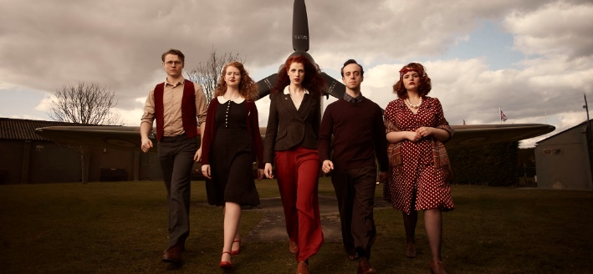
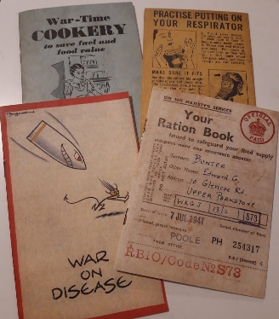 |  |  | Following on from a successful run at the Edinburgh Festival Fringe 2018, as well as the Greater Manchester Fringe and the Altrincham Garrick Playhouse, the Time & Again Theatre Company are now touring the UK! From village halls to RAF hangers, they are proud to be sharing their show and it is perfect for older audiences and vintage fans who love a bit of wartime nostalgia as it provides a window into life on the home front in World War II.
Civic Centre, Sambourne Road
Warminster BA12 8LB
 | TICKET PRICE: £25.00 (includes tea/coffee & a slice of homemade cake)
CLOSING DATE: Tuesday 9th August 2022 (unless fully booked)
(Please note: early closing date due to cancellation clause in Speaker’s Contract)
ENQUIRIES TO: |  | Daphne Atkinson |  |  | Tel: 01985 217658
(no ticket sales) |  |  |  |  | Email: daphneatkinson@wiltshirewi.org.uk
Cheques will be banked upon receipt. Email confirmation will sent – tickets will not be used. If a refund is due for any reason it will be sent accordingly.

