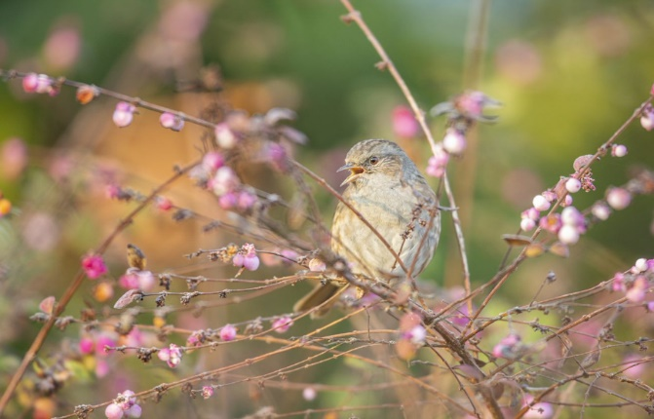
NEW… Huxley Cup Competition 2022
Inspiring women countrywide to create a cleaner and greener place to live

This year, the Huxley Cup Competition, supported by the RSPB (Royal Society for the Protection of Birds), invites WIs to design a small community space for wellbeing and wildlife. The wildlife aspect of the entry should focus specifically on the theme of:

Our Fabulous Flying Friends
Think about birds, bees, butterflies, moths, and bats!

What are we looking for?
The planned space must be accessible and enjoyed by the community. It can be linked to a health care setting (e.g., GP surgery, hospice), or community garden (e.g., community hall), or transforming a grass verge or area in community which has frequent pedestrians passing by (e.g., Village green, car park area, local park flower bed or cycle path).
Designs should be bold and inspiring; the judges will be looking for your idea to be colourful, engaging, and inclusive. Think about growing your own plants, plant sharing, upcycling, re-using, and recycling.

Key components to consider:
- Inspiration behind the design and consideration given to health and well-being, sustainability, wildlife and particularly our flying friends including, birds, bees, butterflies/ moths, and bats.

- Constraints of the location e.g., how the community space is currently being used, and why the community would welcome its transformation.

- Consideration of how the planting area might look throughout the year; think of longevity and seasonality of planting i.e., year-round wildlife benefits and interest for people.
- Longer term maintenance, water uses and upkeep.

- Are there any local charities (e.g., age, disability, or mental health charities), schools or colleges that would also benefit from this area, or who may be interested in working with the WI to create and maintain the area?

- How does the theme and style of the finished plan represent the WI?

- How does the finished plan fit into the NFWI Vision: bold and inspiring, growing and relevant, inclusive and flexible (vision statement can be found on My WI or by contacting the membership team at the NFWI).

Criteria for finished design:
- Design to be no larger than A3 size (1 sheet, single side only); this can be presented in any style (such as a mood-board) and must include site orientation (North/East/South/West aspect), a drawn sketch, a plan of the finished design, in colour and two site photographs.
- The finished design must include a title, with a short, clear vison or message underneath, which captures the inspiration behind the design, both for local wildlife and community.
- Designs can be completed either by hand or electronically.
- The size of the design area can be of any shape, but total size should not be larger than 10 metres².

- The finished planting scheme does not have to be definitive/ exhaustive – just a reasonable indication of planting styles.
- The final design should be submitted together with a clear explanation of the proposed design theory. This must be written separately and securely attached to the design (either on the back of the design entry or as a separate paper). Using no more than 1000 words, the written theory must include:

- Your reasons for choice of planting and resources (e.g., bird boxes, insect hotels etc).
- Wildlife which you might hope to attract and why.
- A brief list of plants and materials to be used, with reasoning e.g., grow your own plants, plant sharing and use of existing planting/infrastructure (e.g., trees, shrubs, hedging, walls, and fencing), recycled/upcycled materials. A mix of herbaceous, perennial and annual plants could be used., and note your thinking about choices e.g. benefits to wildlife throughout the year e.g., flowers, seeds, berries, and scent or draught tolerance etc.
- An explanation of the existing local situation, and background as to why this would be a great spot to develop a community space for wildlife.

How to enter
- This competition is open to all WI members; entries must be submitted on behalf of the WI and not as an individual. Members of the WI are encouraged to work together to compose a design which will then be submitted under the name of the WI, and not a specific individual. Only 1 entry per WI will be accepted.
- The final design can be produced either by hand (no larger than A3, 1 sheet, single sided) or by digital form (completed on any graphic design, Microsoft Office or similar package, maximum file size 4MB).
- Due to the current pandemic, WIs are required to follow government guidance, nationally and locally, at all times throughout the competition.
- WIs must submit their finished design directly to the NFWI (address to be confirmed) for judging (not via federations as per previous competitions, or the RSPB). Deadline for entries is 19 August 2022. Each entry must be accompanied by a WI Entry Form.
- The winning entry, runners up plus a selection of chosen entries will be retained by the NFWI for display purposes until December 2022. The NFWI and the RSPB reserves the right to use images of these entries on organisational magazines, social media channels, websites. Photographs will be acknowledged to the WI. Credit to the winning WI will be given.
- The winning WI will work with the RSPB to allow their design to be published by the RSPB with acknowledgement/credit to the WI winners.

Timescale:

- WIs must send their entry directly to the NFWI (address to be confirmed) no later than 19 August 2022. It will not be possible to accept late entries. All entries must be accompanied by an WI Entry Form.
- It is not possible to return entries to WIs after judging.
- Judging will take place during September 2022 and the winner will be notified as soon as judging is complete.
- A representative from the winning WI will be presented with the Huxley Cup at the Annual Meeting, June 2023 (arrangements to be confirmed).
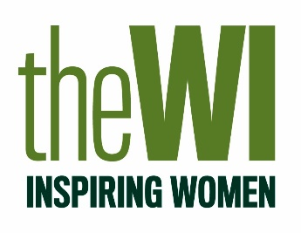
Please note: Entries to this Competition are £5.00 for each entry.

For help, or inspiration for ideas to help with the design, please visit…
Nature on your Doorstep – Wildlife-friendly Gardening | The RSPB

