CHRISTMAS DORSET BUTTONS WORKSHOP
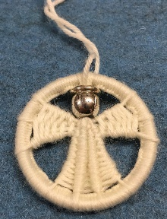 |  | Monday 22nd November 2021  Session 1: 10.00am – 12.00pm  Session 2: 1.00pm – 3.00pm
A Dorset button is a craft-made button originating in the English county it is named after. It is characteristically made by repeatedly binding yarn over a disc or ring former.  Jen Best of https://www.beakerbutton.co.uk/ will show you how to make one or two Christmas buttons in a choice of colours to adorn your tree. |  |  |  | 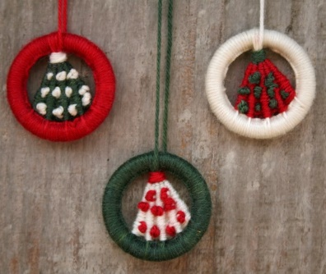
West Lavington Village Hall
Sandfield
West Lavington SN10 4HL
PRICE: £20.00 per person per session per button Includes all materials
CLOSING DATE: Thursday 21st October 2021
ENQUIRIES TO: | Jane Crook |  | Tel: 01264 850436
(no ticket sales) |  |  | Email: crook.jane@gmail.com
Cheques will be banked upon receipt. Tickets will be issued after the closing date. If a refund is due for any reason it will be sent accordingly.

