ANNUAL COUNCIL MEETING 2022
Thursday 20th October 2022
10.30am – 3.30pm
Norwood Hall, Marlborough College,
Bath Road, Marlborough SN8 1PA
(Ample free parking available)
Speakers: Rev Kate Botley and Dr Elizabeth Bruton
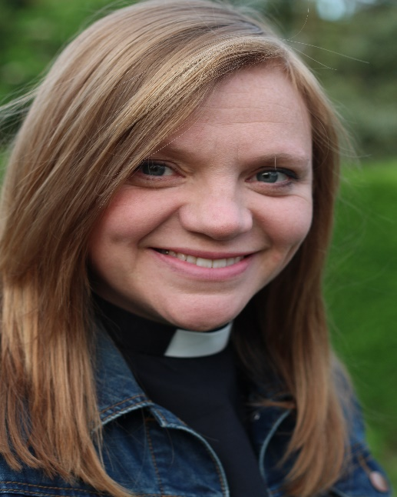 |  | Rev Kate Bottley is a Church of England priest in North Nottinghamshire, a role which she combines with her other roles of journalist, media presenter and reality television star. She appears frequently on British radio and television as well as in newspapers.
As part of Top Secret: From cyphers to cybersecurity, a free exhibition at the Science Museum in London, Irish curator Dr Elizabeth Bruton was part of a team that negotiated unprecedented access to GCHQ’s historical collections and to many of their staff. |  |  | 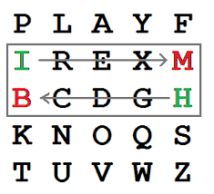
 | TICKET PRICE: £18.00
CLOSING DATE: Monday 12th September 2022
(Unless already fully booked)
Cheques will be banked upon receipt. If a refund is due for any reason it will be sent accordingly.

ANNUAL COUNCIL MEETING TICKET ORDER FORM
THURSDAY 20th OCTOBER 2022

Please send: | 1 | Delegate ticket | £0.00
Please send: |  | Member tickets @ £18.00 each | £
Total Cheque made payable to Wiltshire Federation of WIs: |  |  | £
OR total BACs payment: (ref: YOURWI ACM22) |  |  | £
OR total TryBooking payment: |  |  | £
TryBooking Ref: https://www.trybooking.co.uk/BOTL
TryBooking QR Code: |  | 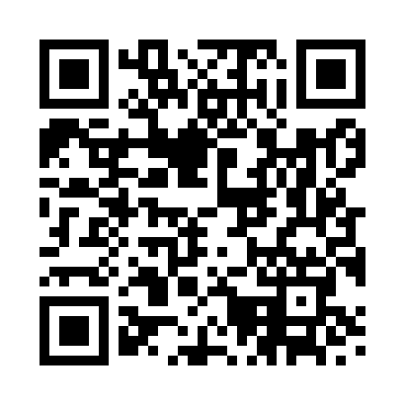

Whichever way you pay you MUST send a STAMPED ADDRESSED ENVELOPE together with the ticket order form to:
WILTSHIRE FEDERATION OF WIs and send to:
WI House
17 Couch Lane
Devizes
Wilts SN10 1EB
Seating is all on one level
Wheelchair Seating – important to order if required
Wheelchair companion seated alongside wheelchair user
WI NAME:
CLOSING DATE: | Monday 12th September 2022 (Unless already fully booked)

