LIVE SPORTS EVENTS - IMPORTANT
The Federation has organised three live sporting events this year:
Bowls Taster Event – Closing Date 16th August
Walking Netball – Closing Date 23rd August
Nordic Walking – Closing Date 16th August
All these events have closing dates that must be adhered to. These are “live” events, and we have to notify other organisations regarding the numbers attending. They require four weeks’ notice of attendance; therefore, cancellation will occur if there are insufficient bookings by the closing date.
Collingbourne Kingston WI
After many wet and windy days Collingbourne Kingston WI were unbelievably lucky that the sun shone on Thursday 8th July. This was a date they were all looking forward to, the first face to face meeting since Lockdown in March 2020. They had had various Zoom calls, meetings in a bag, permitted walks in small groups and a picnic tea in the grounds of the Village Hall between the lockdowns. July has traditionally always been their Summer Party, and fortunately the restrictions eased enough to allow a get together this year. They met in a member’s garden to play games and have a picnic which They individually brought with them.
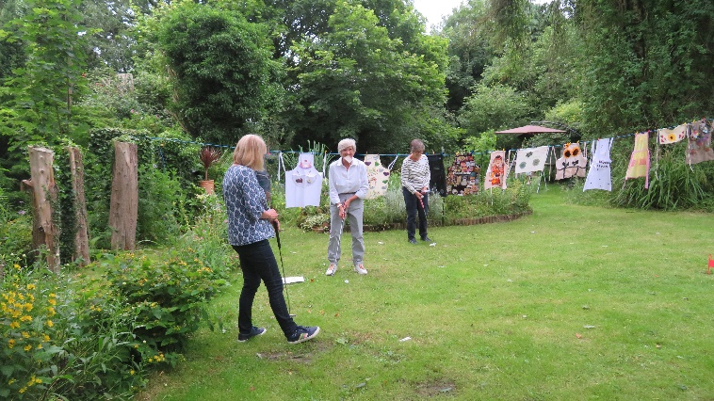The committee supplied some delicious deserts with tea and coffee and topped it off a glass of Pimm’s to celebrate the reunion.
Seventeen of the twenty-one members entered the competition ‘A Decorated Apron’ - judging was exceedingly difficult, said the house owner, as they were all so good. The winner was Laura Renwick who had hand painted hers.

The Ladder Toss was won by Karen Preece, who managed to get 80 points tossing bean bags into the rungs of a ladder. The third game was ‘Hunt the items not usually found in a garden’ and when they were found, a relevant question had to be answered. All members were winners and received some sweets.
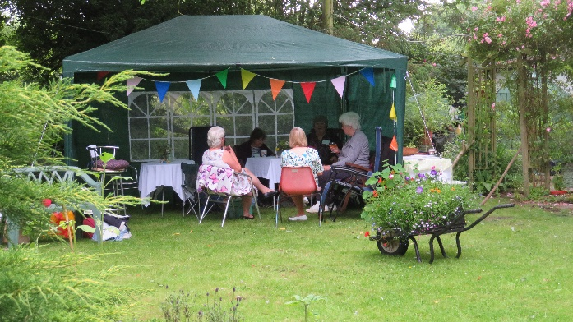
This was a very enjoyable evening it was so nice to see smiles on the members faces - they look forward to more successful meetings in the future when they can get back to Collingbourne Kingston Village Hall on August 8th. Fingers crossed!

WFWI Annual Meeting – via Zoom
Saturday 16th October 10.15am – 1.30pm
(Including a short interval)
We have a wonderful morning of entertainment planned for you at our Annual meeting. First we have Tracy Daszkiewicz
Who will tell us about the Salisbury poisonings. Tracy was the director of Public Health & Safety for Wiltshire and she played a leading role in the response to the Novichok attack of Sergei and Yulia Skripal in 2018.
Following Tracy we have
Mary-Jess Leaverland.
Mary-Jess, who hit the headlines after winning Chinese X Factor-style singing competition Min Xing Chang Fan Tian, that had over 70 million people watching, also had her second single “Glorious” picked as the official Rugby World Cup 2011 song. Mary -Jess also recorded the new theme tune for ITV1's popular period drama Downton Abbey.
Tickets are £5.00 each and are available from WI House or online by going to https://www.trybooking.co.uk/BCKY and booking online

Wiltshire News
We were hoping to be able to produce a printed issue of “Wiltshire News” for September. However not enough articles were sent to make producing a magazine possible. We are now hoping to produce an issue for October. If you have pictures and news about your WI that you would like to be included in that issue, please send them to fedsec@wiltshirewi.org.uk by 31st August.
Winturwell WI – Puppies Galore
Winturwell WI took part in the Scarecrow Trail in Winsley over the summer half term. The subject this year was Children’s Books and Films, and they submitted their entry of 101 Dalmatians. They didn’t quite make the 101 but - with a series of footprints they gave the illusion that the rest had already gone by leaving this group just resting with their Mum, Perdita. The dogs were sewn and knitted using left over materials and wool and stuffed using old cushion fillings.

Following getting rained on the group came together again in the President’s Garden to show to all of those who lived further afield and had not seen them. This was Winturwell’s first face to face meeting and included their Annual Meeting.

The dogs were then invited to a wedding. In this case The Scarecrow’s Wedding, performed at Church Farm, Winsley on the first weekend in July. This time they got really soaked in the rain and had to come back to be dried off before being returned to their makers.

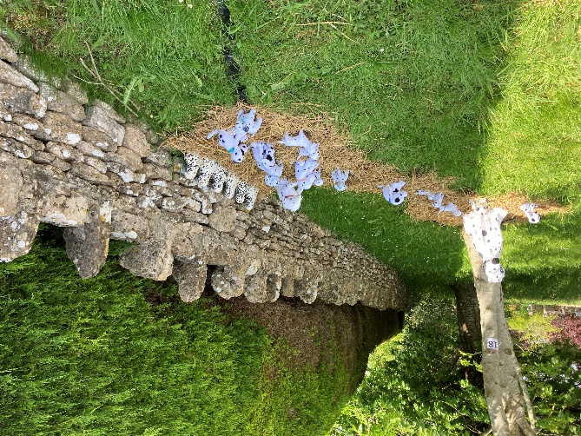

101 Dalmatians in Scarecrow Trail

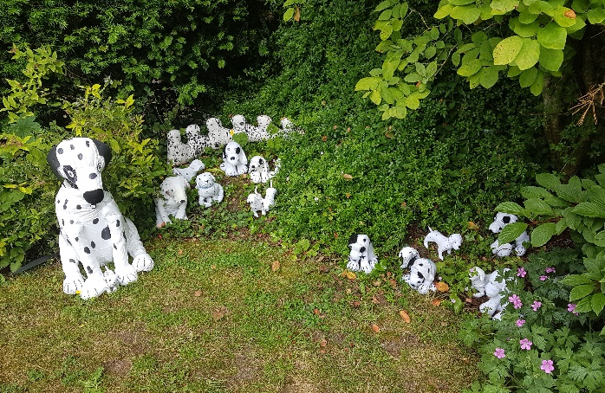

Market Lavington WI.
Market Lavington WI recently enjoyed a lovely summer evening get together at one of their member’s farm.

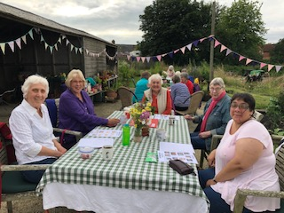
Members brought their own picnic, they played a quiz, there was lots of chat and ice cream to finish.

Beautiful scenery along with chickens, ducks, goats & a very friendly farm cat!
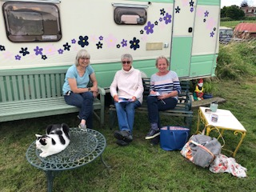

WFWI HOLIDAYS ARE BACK!
The Federation are pleased to announce that holidays are back. We are staying in the UK next year. We are hoping to visit the bulb fields in Holland in the future, but feel that travel outside the UK is not yet advisable so we hope you will enjoy travel to:
Holiday to Bedfordshire 9th – 13th May 2022 – Including Bletchley, Woburn, Duxford & much more.
Application forms available from WI House now, your WI secretary also has an email version with all the details. Details wil also be available on the WFWI website www.wiltshirewi.org.uk
Holiday to Oxfordshire 24th – 28th October 2022 – Including Oxford, Blenheim and the River Thames.
Details to follow later in the year.
As with all WFWI holidays there will be plenty to see and do, all based from a really nice hotel.

