NORDIC WALKING
TUESDAY 14TH SEPTEMBER 2021  9.30AM – 11.00AM |  |  |  |  | 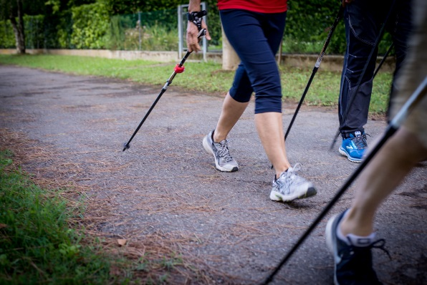
Nordic walking is a total body version of walking that can be enjoyed by non-athletes as a health-promoting physical activity. The activity is performed with specially designed walking poles similar to ski poles.
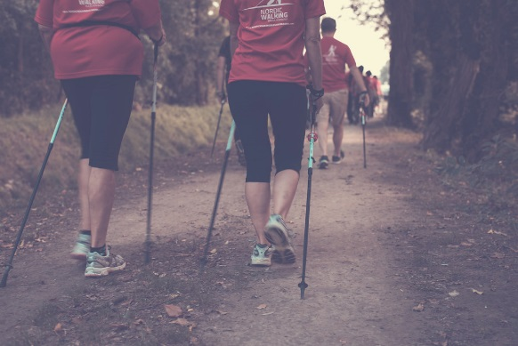 |  |  | Meet in public car park in  Castle Combe Village at 9.15am  2 hours free parking  Dunns Lane SN14 7HU
 | PRICE PER TICKET: £12.00
CLOSING DATE: 16th August 2021
ENQUIRIES TO: |  | Kate Crawford |  | Tel: 01380 850395
(no ticket sales) |  |  |  | Email: assttreasurer@wiltshirewi.org.uk
Cheques will be banked upon receipt. Tickets will be issued after the closing date. If a refund is due for any reason it will be sent accordingly.

