LITERARY LUNCH & TALK
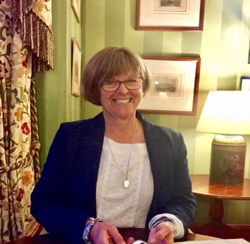  Nicola Pryce |  |  |  | Thursday 27th January 2022  From 12.30pm  Venue & Price Update
Nicola trained as a chemotherapy nurse before completing an Open University degree in Humanities. She is a qualified adult literacy support volunteer and lives with her husband in the Blackdown Hills in Somerset. Together they sail the south coast of Cornwall in search of adventure.
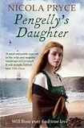 |  |  | Leigh Park Country House Hotel, Leigh Road  Bradford-on-Avon BA15 2RA  Entry from 11.00am. Lunch: 12.30pm for 1.00pm  Talk begins at 2.15pm |  |  |  | 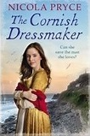
Ticket Price: £29.00 includes 2 course hot lunch with tea and coffee.
(Upon booking, menu choices will be made available)
CLOSING DATE: 3rd January 2022
ENQUIRIES TO: |  | Daphne Atkinson |  |  | Tel: 01985 217658
(no ticket sales) |  |  |  |  | Email: daphneatkinson@wiltshirewi.org.uk
Cheques will be banked upon receipt. Tickets will be issued after the closing date. If a refund is due for any reason it will be sent accordingly.

