GET TO KNOW YOUR SEWING MACHINE (Part 2) EXPLORING YOUR FEET!
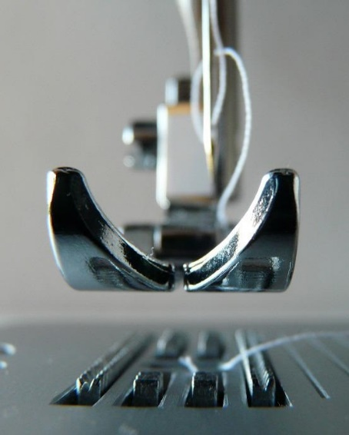 |  |  | Friday 5th August 2022  or  Saturday 6th August 2022  10.00am – 3.30pm
 |  |  | WI House, 17 Couch Lane  Devizes SN10 1EB  Note: Craft room is upstairs – assistance can be given carrying machines. |  | 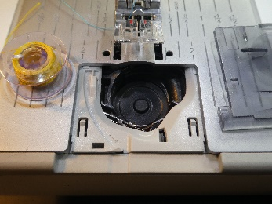
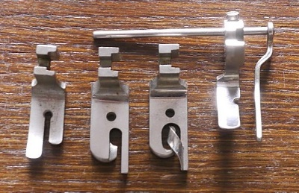 |  | Attendees will need to check their machine is in good working order before the class. Ensure you bring pedal, lead, and the instruction manual.  Also, please bring a basic sewing kit of small and large scissors, pins and a pencil.  You will be able to produce a decorated bag and a small selection of samples. All materials included.
PRICE PER PERSON PER SESSION: £35.00
(please bring a packed lunch)
CLOSING DATE: Monday 11th July 2022 (Unless fully booked)
ENQUIRIES TO: |  | Louise Hall |  | Tel: 01722 326549
(no ticket sales) |  |  |  | Email: louisehall@wiltshirewi.org.uk
Cheques will be banked upon receipt. Email confirmation will be sent – tickets will not be used. If a refund is due for any reason it will be sent accordingly.

