DITCH THE PLASTIC
Tuesday 26th October 2021
From 7.00pm
Via Zoom
 |  |  | Zoom talk with Wendy Paton who featured in the May/June 2021 issue of WI Life.  Learn how small, everyday actions can reduce the use of plastics which are harmful to the environment. Every little act adds to the big effort to reduce plastic pollution. |  |  |  | 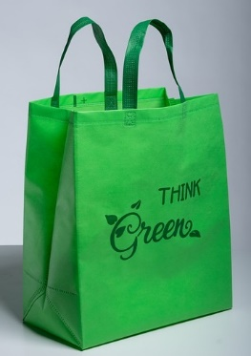
 | PRICE PER DEVICE: £5.00
CLOSING DATE: Tuesday 12th October 2021
ENQUIRIES TO: |  | Lesley Holdway |  |  | Tel: 01225 782092
(no ticket sales) |  |  |  |  | Email: chair@wiltshirewi.org.uk
Cheques will be banked upon receipt. Tickets will be issued after the closing date. If a refund is due for any reason it will be sent accordingly.

