CHRISTMAS CELEBRATION 2021
 |  | Tuesday 7th  December 2021  2pm – 4pm |  | 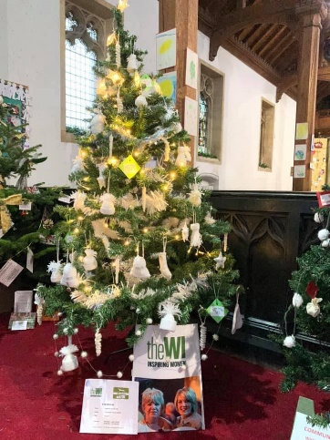
“A warm welcome
from our home to yours.”
Via Zoom
£5 per Device
CLOSING DATE: 30th November 2021
ENQUIRIES TO: | Lesley Holdway |  | Tel: 01225 782092
(no ticket sales) |  |  | Email: chair@wiltshirewi.org.uk
Cheques will be banked upon receipt. If a refund is due for any reason it will be sent accordingly.

