WALKING NETBALL
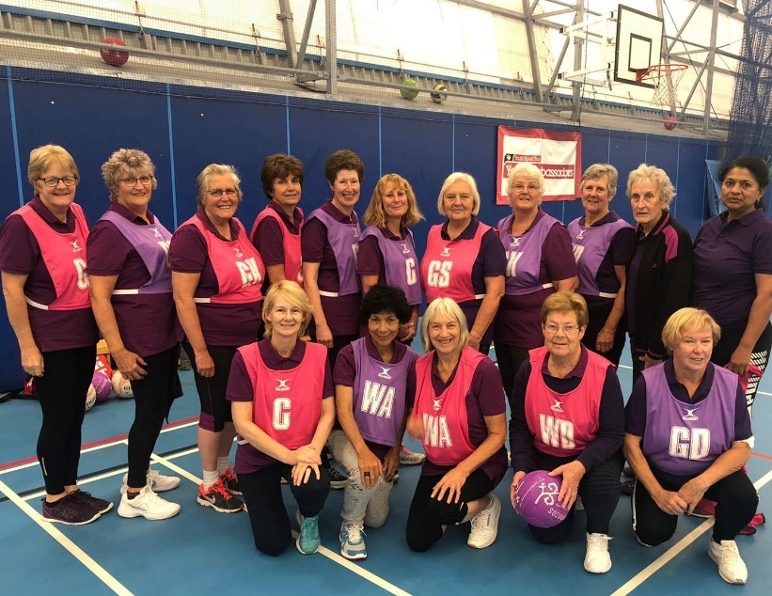 |  |  |  | Saturday 11th September 2021  1.00pm – 3.00pm  Chippenham Sports Club (The Air Dome)  Hardenhuish Park  Bristol Road  Chippenham SN15 1NH
A taster session giving you the chance to revisit an old school sport or try something new. Suitable for all ages and abilities this is an opportunity to exercise in a relaxed, supportive, friendly and fun way!
 | PRICE PER TICKET: £5.00
CLOSING DATE: Monday 23rd August 2021
ENQUIRIES ONLY: |  | Carla Smith | Tel: 07740 141738
(no ticket sales) |  |  | Email: smithcarla1961@gmail.com
Cheques will be banked upon receipt. Tickets will be issued after the closing date. If a refund is due for any reason it will be sent accordingly.

