WORKING WITH THE GHOSTS OF HAMPTON COURT PALACE
Sarah Slater
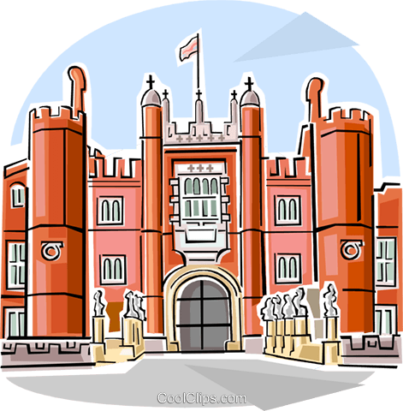
Sarah, a Warden and Tour Guide at Hampton Court Palace, will share with you her experiences of working with the ghosts at this historic building: the history, the stories and the sightings. Well worth attending as she has been recommended by some WIs within Wiltshire.
Monday 5th July 2021
10.30am – 12.00pm
Via Zoom
£5.00 per device
Closing Date: Monday 21st June 2021
ENQUIRIES TO: | Daphne Atkinson | Tel: 01985 217658
(no ticket sales) |  | Email: daphneatkinson@wiltshirewi.org.uk
Cheques will be banked upon receipt. Tickets will be issued after the closing date. If a refund is due for any reason it will be sent accordingly.

